**Lowestoft RC Coastal Sculling Academy**

**Last Light Regatta**

**6th October 2024**

**Safety Plan**

The aim of this event is to introduce as many people in the Eastern region (& beyond) as possible to Beach Sprint racing and to bring Lowestoft Coastal Sculling Academy to their notice. We would like to inspire some to go on to train for these events and to be supported by others in their clubs. This needs many people to have an idea of the sport & who will be able to boathandle & signal for club members at major national events.

Additionally we are hoping to create the opportunity for umpires to learn the format and be confident enough of the roles in order to volunteer for the major championships.

This Safety Plan has been formulated to meet the Last Light Regatta’s Organising Committee's responsibilities.

**● Regatta Safety Adviser:** The Regatta Organising Committee has appointed **Reuben Frost** (Mersea Island Rowing Club, Eastern Region Rowing Council Rep and Helm of the Mersea RNLI lifeboat) as the Regatta Safety Adviser. He is a member of the Organising Committee and has reviewed this document and the Regatta Risk Assessment (available for viewing on the website).

● **Regatta Race Committee:** A race committee of three licensed umpires will be chaired by the Race Committee Chair **Jo Cotgrove**, the co-ordinating umpire and the umpire at the start.

The Race Committee will undertake the duties detailed in the BR Beach Sprint rules of racing (see Rules 15 Appendix F2) <https://www.britishrowing.org/wp-content/uploads/2024/03/2024-British-Rowing-Rules-of-Racing-V1.pdf> . There will be some local modifications to allow the competition to proceed as a round robin event rather than as series of time trials followed by knockout races as this will allow more people to get more race experience.

In particular, they will decide (in consultation with the Regatta Safety Adviser) whether conditions are too dangerous to permit racing to continue.

● Row Safe: A Guide to Good Practice in Rowing ('Row Safe'): It is compulsory that all crews attending comply with all aspects of Row Safe. It is the responsibility of the competitors & boathandlers to ensure that their boats are safe and are prepared to standards required by Row Safe. All club/crew coaches are to ensure that their crews are correctly briefed on Row Safe, particularly in relation to capsize procedures.

● Circulation pattern and competitors’ instructions: All competitors, coaches and other participants must familiarise themselves with the Regatta circulation pattern as described in the Competitors’ Instructions. They must follow all posted safety notices and obey instructions from Regatta Officials.

● **First Aid**: First Aid facilities are provided next to registration and will be signposted. Any junior requiring first aid treatment should be escorted to First Aid by a responsible adult, who will be expected to remain with the junior throughout his/her stay.

● **Safety Cover:**

There will be 2 rescue launches stationed towards the top corners of the course. Additional safety equipment as specified by Row Safe will be carried in the launch. The drivers will have a radio, as will race control. Each rescue launch will have a megaphone for emergency steering advice to competitors.

Umpires are all on the beach /sand and will report to the senior umpire of any infringements.

The senior umpire will have a megaphone to communicate to the boat handlers and to the rowers

● **Emergency Action Plan:**

The Race Committee Chair **Jo Cotgrove** will be contactable on mobile phone

,and must be advised immediately of any incident:

● involving danger of, or actual, significant injury;

● requiring consideration of suspension of racing;

● involving loss of facilities required for safety and public health

The Race Committee Chair will coordinate communication to the Race Umpires, Race

Control, Starter and other officials, and (as appropriate) Emergency Services. Any notification of the emergency services, including the Ambulance Service and/or the coast guard will be made through the First Aid Station or the Race Committee Chairman.

**● Accident and emergencies:**

o The regatta has 3 radios one on each safety launch & one at regatta control. In order to summon safety help for an incident on the water, please contact the nearest safety launch who will inform race control. On land, please contact Race control.

o Racing may be suspended if an incident has occurred anywhere on the course. Should the

regatta need to be suspended or cancelled, umpires will be notified and they will then advise

competitors by loudhailers.

o Radio silence may be called for except from those involved in dealing with the incident to

allow additional help to be summoned if required. Radio users will be advised when

conditions return to normal.

o The First Aid Station or Race Committee Chair will initiate any "999" call by mobile phone

should the incident require assistance beyond the scope of that available on the Regatta site.

The Safety Adviser or Race Control will alert competitors and spectators on the beach of the imminent arrival of emergency services, provide a point of contact and clear directions to the incident

● **Thunderstorm safety plan**

o If the time between hearing thunder and lightning is 30 seconds or less (and the direction of the thunderstorm is close to or passes over the course) then we will evacuate all personnel from the sea and advising all competitors, members of the public and regatta staff

to take shelter. The Race Committee will make the decision once severity and direction of

a storm is established.

o Racing will not restart until 30 minutes after the last audible roll of thunder.

**● Other sea users:**

o Occasionally there may be other sea traffic that might want to traverse the area. Everybody should be alert to this possibility and every effort will be made to warn people. Races will not be started until the course is clear.

o The safety boats will alert traffic (swimmers, sailors various) to the fact that racing is in progress.

● **Insurance**: Please note that the personal accident insurance through your British Rowing membership has limited validity. In particular, if there is any doubt about members' UK residence, it is best to clarify coverage with British Rowing. We cannot be responsible for interpreting the coverage they have purchased on your and our behalf.

**● Regatta Incidents**: All safety-related incidents, including "near misses", must be reported to Race Control in the gazebo who will record them and file an incident report with British Rowing.

**● Distribution of data:**

o This Safety Plan which includes Competitor Instructions and race pattern will be freely

available on the club’s website. All competing clubs, umpires and race officials will receive an electronic copy.

**Specifics**

The racing will take place on Lowestoft Beach between the South Pier & Claremont Pier, opposite the Hatfield Hotel with race control being set up in the vicinity of what3words///kicks/herb/never.

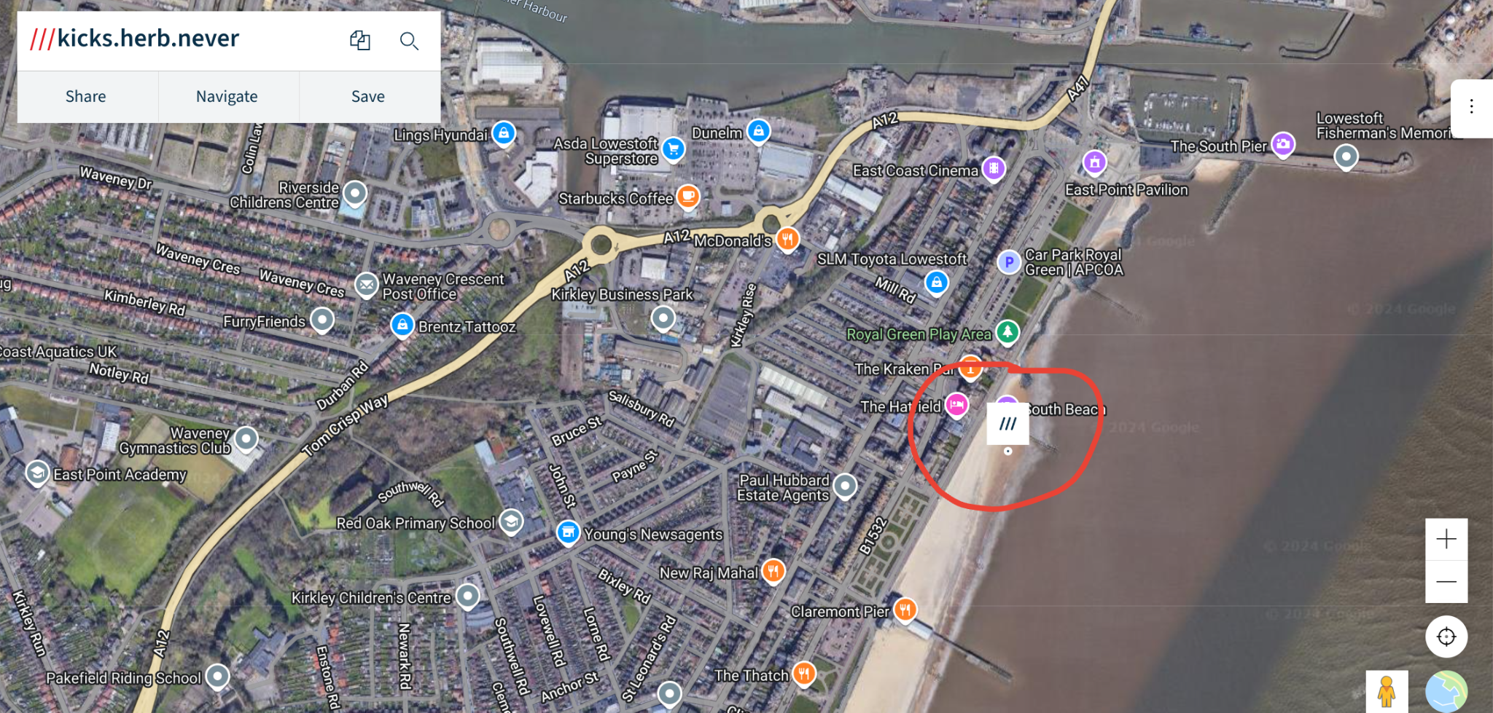

The racing will take place as a 3 or 4 lane round robin event (depending on conditions and entries) with the winners of each category awarded on total time taken for each run.

This allows for people to race on the water against people not in their event category.

The categories shall be Female & Open

J16, J18, U23, Senior, Masters C and below, Masters D and above.

The event will be run as Option B of the Fisa rules; i.e. slalom out and straight back in groups of threes

The finish will be touching a flag on the finish line.

Competitors will race in all (or 3 of the 4) lanes, to reduce the effect of any lane being more favourable.

The boats, buoys and course set up will be provided & organised by **Swift Racing**

In the event of weather proving to be too dangerous on the sea, the event can transfer to Oulton Broad and be run as a free water start on the Broad.

**Boat Handling** will be provided by other competitors, as this is another skill lacking in the Eastern region and will be an essential skill needed to be able to compete at the large national championships. It is also a skill needed for the England & GB team- and performed by the reserve athletes.

Getting in & out of boats instruction will be provided in a session prior to racing on the beach. It will also include boat handling.